OPL Gallery Floor Plan
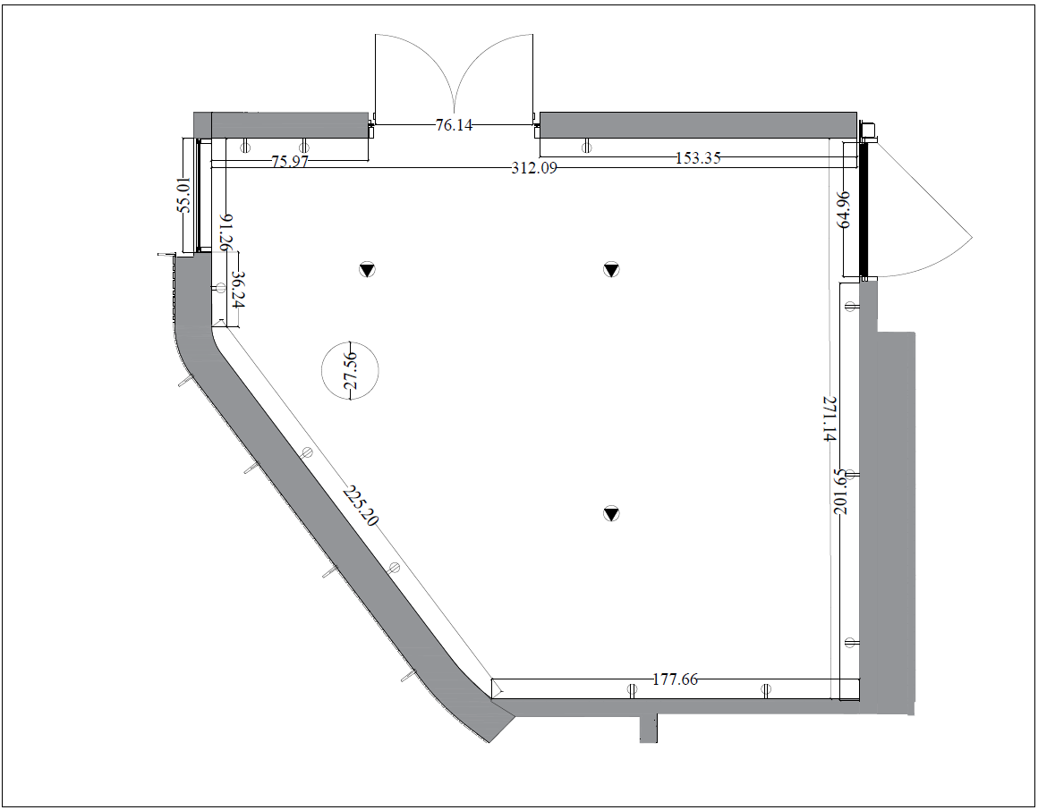

OPL Gallery - Floor Plan Dimensions
Area | 516.66 ft²
Ceiling height | 14.43 ft
North wall - overall | 312.09 in
North wall - section 1 | 75.97 in
North wall - entrance doors | 76.14 in
North wall - section 2 | 153.35 in
East wall - overall | 271.14 in
East wall - storage room door | 64.96 in
South wall - overall | 177.66 in
Column in front of west wall (diameter) | 27.56 in
West wall - overall | 316.45 in
West wall - section 1 | 225.20 in
West wall - section 2 | 36.24 in
West wall - window | 55.01 in

*Dimensions may vary based on site considerations
*Dimensions in the plan are in inches

